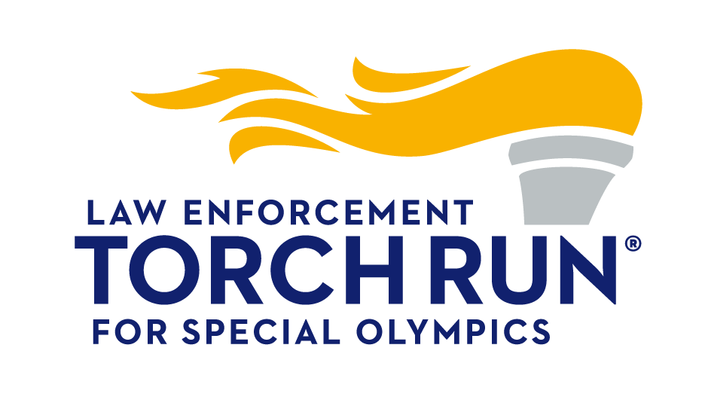

2026 Richard LaMunyon Hall of Fame

Nomination Form

NOMINEE

Nominee’s Name:

Phonetic Spelling of Name:

Address:

Street/Town/Suburb/City

State/Province/Zip/Postcode

Country

Phone:

Cell/Mobile

Email:

Program Name:

LETR / Special Olympics

NOMINATOR

Nominee’s Name:

Address:

Street/Town/Suburb/City

State/Province/Zip/Postcode

Country

Phone:

Cell/Mobile

Email:

Program Name:

LETR / Special Olympics

VALIDATION

Please note for the nominee to be considered, the Committee Chair may seek to contact the Special Olympics Program CEO or LETR Program Director to validate that they approve and support this nomination

Name of Special Olympics CEO:

Email Address:

CEO has endorsed nomination?

Yes, No or N/A response required

Name of LETR Director:

Email Address:

TRD has endorsed nomination?

Yes, No or N/A response required

Nomination Form (Continued)

Please answer each of the questions below to highlight activities, length of service, contributions, accomplishments, money raised, sponsors acquired, and volunteerism positions held by your nominee. Please be specific and provide examples as necessary. Use additional space if needed – simply continue typing in the cell.

1. How many years has the nominee been involved with the Law Enforcement Torch Run?

[Enter response here]

2. Provide detailed examples that demonstrate the nominee’s outstanding achievements and successes in LETR development, organization and fund raising at a local, state or provincial level.

[Enter response here]

3. Provide detailed examples that demonstrate the nominee’s outstanding achievements and successes in LETR development, organization and fund raising at a national or international level.

[Enter response here]

4. Provide detailed examples that demonstrate the nominee’s exceptional leadership, commitment and dedication that have made a significant impact on furthering the mission of the Law Enforcement Torch Run at a local, state or provincial level.

[Enter response here]

5. Provide detailed examples that demonstrate the nominee’s exceptional leadership, commitment and dedication that have made a significant impact on furthering the mission of the Law Enforcement Torch Run at a national or international level.

[Enter response here]

6. List any other information you believe the selection committee should know about the nominee.

[Enter response here]

NOMINATION SUBMISSION NOTES

For the nominee to be considered, the completed nomination form must be received no later than 5:00 p.m. ET, June 30, 2026, and accompanied by:

- Two (2) letters of support from people who have worked closely with the nominee.
- Six (6) to eight (8) digital photos meeting the listed photograph requirements.
- Resolution: Minimum of 2 megapixels (1920 x1080)
- Orientation: Landscape
- Framing: Avoid closely cropped images
- Content: Single photos of the nominees are preferred; images that include athletes or the torch especially appreciated.
- Knowledge & approval of the Special Olympics Program CEO and the LETR Program Torch Run Director.

